PYQ

## 2021 –

* UCBs brought into BRA through an amendment in 1966. They can issue equity shares + preference shares
* CDSL – BSE + SBI + HDFC + etc.

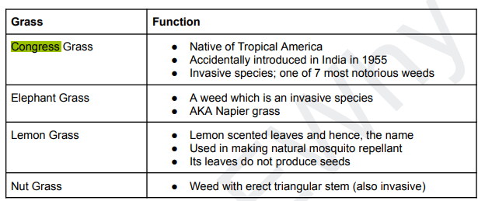

* Colours of Carbon –
  + **Purple**: Carbon that's been captured from the air or **industrial emissions**
  + **Blue**: Carbon that's stored in ocean plants and sediments, such as mangroves, salt marshes, seagrasses, seaweed, and sediments
  + **Teal**: Carbon that's stored in freshwater and wetland environments
  + **Green**: Carbon that's stored in terrestrial plants, such as in soils and within biomass like forests
  + **Black**: Carbon that's released when fossil fuels are burned
  + **Gray**: Carbon that's released through **industrial emissions**
  + **Brown**: Carbon that's released when organic matter is incompletely combusted
  + **Red**: The newest color in the carbon spectrum, red carbon includes all living biological particles on snow and ice that reduce albedo to survive
* Mutualism –
  + Cnidarian – Algae
  + Fungi – Plants = Mycorrhiza
  + Frogs – Tarantula
  + Crab – Sea Anemone
  + Fungi – Ant
  + Protozoa – Termite
  + Cockroach – Mite

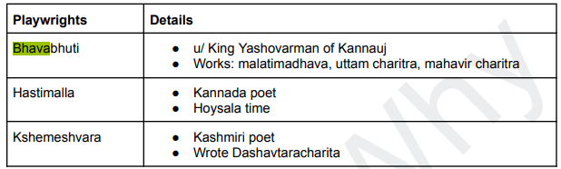

* Pargana < Sarkar < Suba

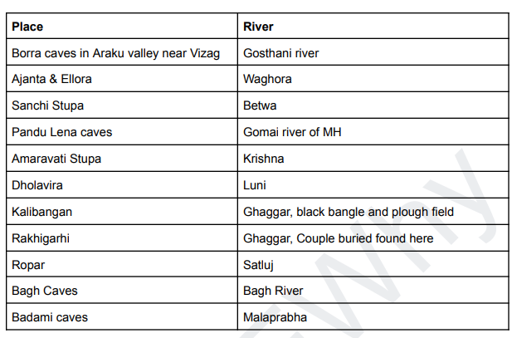

* Palm oil is used to produce biodiesel. Palm oil is native to Africa.
* Moringa – Evergreen/Deciduous + non-leguminous + India is largest producer + Mostly MFP
* Tamarind is indigenous to Tropical Africa. KN > Kerala in production.
* Triclosan – Present in Toiletries.
* Patabhi Sittaramaiah led the QIM in Andhra from Kurnool. He was defeated by SC Bose in 1939 INC elections.
* 2024 Olympics –
  + Breaking Sports – Skateboarding, Surfing, Climbing
  + Motto – “**Games Wide Open**”
* Crude oil products (Petrol, Diesel etc.), **Automobiles, Tobacco smoke and wood burning** are direct sources of Benzene pollution, while Industries are not.
* Offices of profit not eligible for disqualification to becoming a MP are listed in Parliament (Prevention of Disqualifications) Act. 1959
* EPA,1986 – Does not mention public participation.
  + Public participation is mentioned in the EIA notification, 2006.
  + Under EPA, no court can take cognizance of an offence except –
    - The Central govt or a statutory body under it complaints about it.
    - A person after submitting a 60-day notice to the Central govt approaches the court.
* PNGRB appeals go to the appellate tribunal for electricity.

## 2011 –

* Bio-asphalt – Made from renewable sources. The main adhesive is Lignine as opposed to Bitumen in Traditional Asphalt which is produced in TPP.
* Microbial Fuel Cells – Using Algae in the Cells to generate electricity. It may be used in wastewater treatment. Algae break down the organic material in the water, release electrons that are used to harness energy.
* Dist. Planning Committee, Metropolitan Planning Committee – Constitutional - 74th CAA
* Girdling – Cutting a ring on the bark of a Tree – Phloem is removed – Nutrient transfer stops – Tree dies.
* Tropical Rainforests regenerate slowly if completely removed due to low soil nutrients.
* Karl Marx – Dialectical Materialism – Explains the transition from Capitalism to Socialism
* Heavy Water in Nuclear Reactors => Coolant + Moderator
* National Minority – PM 15-point program
* Rights or Persons with disabilities Act –
  + Free schooling till 18
  + Incentives for business
  + Ramps in Public places
* Indian Wild ass (Rann of Kutch) has no predators in its habitat.
* Bluetooth – 2.4GHz only
* Biodiversity – Prevents Soil erosion, Aides soil formation, Recycles Waste, Pollinates crops.
* LED lifespan is longer than CFL.
* Orchids – Arunachal Pradesh
* IMF only grants loans to member countries.
* Jain Philosophy – Universal Law
* Teaser Loans – Offer lower interest rate initially, and then they are hiked.
* No Clouds, Water Vapor, Vertical Winds in the Stratosphere
* GJ – More Cash crops

## 2012 –

* National Biodiversity Authority checks for biopiracy, and its approval is mandatory to seek IPR for genetic/biological resources.
* Consumers Act – Consumer has the right to take a sample for food tasting.
* Biopesticides – Bacteria, Fungi, Flowering Plants
* Lead poisoning – Smelting units, Paints.
* CFCs – Non-flammable, Non-conductive, blowing agents, chemically stable – Not used in tubeless tires. Used in Plastic Foams, Cleaning agents, Aerosols.
* Expansion of Universe evidence – Red shift phenomena in space, CMB
* BR Ambedkar – All India Scheduled Castes Federation, Independent Liberal Party
* Ryotwari – The lands were surveyed before being taxed. The Ryots were given Pattas.
* Sea Buckthorn – Nutritional and medicinal Value – Adapted to High altitudes.
* GJ – Largest area of wetlands in the country
* In India, Inland wetlands area is greater than coastal wetlands area.
* Air temperature decreases with altitude – Less Dense + Heating only from below.
* Ocean acidification does not have a direct effect on cloud seeding/cloud formation.
* Janani Suraksha Yojana – Provides monetary assistance for institutional delivery.
* Delimitation commission – Their orders can not be modified by the Legislatures.
* Thorium as compared to Uranium – More abundant, less harmful waste, More energy per unit mass.
* Dhrupad – Originated in the Vedic period – Sanskrit devotional songs.
* **Government borrowing money from the Central Bank increases the Money Supply**.
* China is the largest producer of REE.
* Bhitarkanika is not a TR.
* Bandipur NP is a TR
* The duration of Monsoon decreases from South to North India.
* People are not allowed to collect Biomass in NPs
* Pollination animals – Bat, bird, bee
* Animals found naturally in India – **Black necked crane**, Flying Squirrel, Snow Leopard, Star Tortoise, Pygmy Hog, Monitor Lizard, Leatherback Turtle (Endangered), Swamp Dear (Endangered), Gharial (Endangered)
* Animals **NOT** naturally found in India – Spider Monkey (SA), Marsupials (Aus)
* Zero Tillage – Helps in Carbon Sequestration
* Artificial Sugars –
  + Aspartame = 200 times sweeter than Sugar
  + Sorbitol = 60% as sweet as sugar

## 2013 –

* Sugar industry by products => Bagasse and Molasses
  + Bagasse is used => Fodder, Fuel, Paper manufacture
  + Molasses => Flavouring, Ethanol production, Fodder
* Narmada flows to the west because it follows a linear rift valley.
* Namdapha – Mishmi Hills
* Nokrek – Garo Hills
* Assam’s highest hill range – Bareil range
* There is no Ecological succession from Grasslands to Forests in Grasslands because of Fire, Water scarcity.
* Biological Productivity = Total amount of biomass produced by living organism in each period, in each area –
  + Mangroves > Grasslands > Lakes > Oceans
* Aflatoxins are produced by Moulds (Fungi) due to improper handling of cereals and seeds – Carcinogenic.
* India has banned DDT, the only user of DDT currently is MoHFW – It sprays it on malaria-infested houses.

* Nostoc is a biofertilizer.
* Agaricus is an edible mushroom.
* Minerals needed for contraction of muscles – Calcium, Iron, Sodium
* Dadu Dayal – 16th Century
* Lepakshi Temple (AP) – Murals – Veerabhadra god – Vijaynagar period
* Indian coal – High ash fusion Temp (1200 C) – Low Sulphur content

* The Council of Ministers is collectively responsible to the LS (not parliament)
* Economic and Social Planning – Concurrent List
* Constitution – Panchayats should develop plans for economic development and social justice.

* Mycorrhiza – Enabled Plants to – resist disease, tolerate extreme pH, Resist drought, increase absorptive surface area.

## 2014 –

* Sustainable sugarcane initiative – NABARD -
  + Drip irrigation, Low cost of seeds, Scope for intercropping, Optimum Fertilizer
* **Nicobar – (The Grand Channel) – Sumatra – (Sunda Strait) – Java**
* Saramati Peak – Nagaland
* Dampa TR – Mizoram, **Gumti WS – Tripura**
* Brominated Flame retardants – Resistant to degradation – Bioaccumulation
* Lichens = Algae + Fungi

* Sales Tax – Imposed and Collected by the state government.
* Arab Springs – Started in Tunisia
* Changpa community – Ladakh – Pashmina wool
* Biodiesel/Biofuel –
  + Can be used – jatropha, Pongamia Pinnata (Karanja), Tamarind, Moringa, Maize
  + Can not be used – Neem, Sea buckhorn, Guar.
* Guar – Shale gas extraction
* Ranthambore – Banas and Chambal
* Keoladeo – Banganga and Gambhir
* Cassini-Huygens - Saturn,
* Messenger - Mercury,
* Voyager 1 and 2 - Exploring the outer solar system.
* Areca Nut – Tropical Crop (KN)
* Kinnaur – HP, Mewat – Haryana
* Chanderi (MP), Kancheepuram (TN) – Sarees
* National Seeds policy – 2002
* Eco-sensitive Zones – estd under EPA

## 2015 –

* Decrease in Tax to GDP => The Govt is collecting lesser fraction of the output as tax, maybe because of slow economic growth.
* ITCZ does not occur in Southern Atlantic/SE Pacific.
* Sultanpur NP – Haryana
* National Innovation Foundation – Grassroots Tech innovation – Autonomous under MoST.
* Omkareshwar Temple – Narmada
* Srirailam – Lord Mallikarjun Temple – AP – Nallamala Hills
* Nanotech can contribute to gene therapy.
* NFC – Contactless

* Green Climate Fund –
  + COP16 of UNFCCC, Cancun – 100Bn USD annual payment – Adaptation and mitigation – WB is trustee.
* Amnesty International – Global HR movement
* Biocarbon fund initiative – WB
* ASEAN – LIMCA TV
  + ASEAN + 3 – Japan, S Korea, China
  + East Asia Summit = ASEAN + 3 + Ind + Aus + NZ + USA + Russia
* GEAC – EPA, 1986
* Seed village concept – villagers are trained in quality seed production to allow for local affordable availability of seeds.
* IREDA is a government NBFC that finances RE projects.

## 2016 –

* UNCCD does not have a specific focus on African/S Asian countries. It emphasizes on local participation.
* WB participates in IMFC meetings –
  + IMF is advised by IMFC (24 governors) & Development Committee (24 Ministers)
* Sittars – Community in TN – Monotheists who condemn idolatry.
* Great Indian Hornbill (VU) – State bird of **Kerala & Arunachal Pradesh**
* **Stand up India Scheme –** Entrepreneurship for SC/ST/Women – SIDBI refinance.
* Globally Important Agricultural Heritage System – FAO
* Project Loon – Google – Internet connectivity through stratospheric balloons
* Kharai Camel – Kutch and RJ – Can swim up to 3 km in seawater – Feed on mangrove.
* Virus that infects Fungi – Mycovirus
* NIMZs in India - Prakasam **(Andhra Pradesh), Sangareddy (Telangana), and Kalinganagar (Odisha)**
* Shale Gas –
  + Cambay basin (GJ), Krishna-Godavri basin, Kaveri basin
* ISA – Founded in COP21 Paris agreement.
* MH state butterfly – Blue Mormon

## 2017 –

* MPC – Decides RBI’s benchmark interest rates.
* EU – Digital Single market strategy
* Int’l Panel on Fissile materials – India is a member – Independent group containing experts from many states.
* Nuclear Security Summit – USA
* Ports in AP =>

* Global Climate Change alliance – Initiative by EU
* Sautrantika & Sammitya – Budhist sects

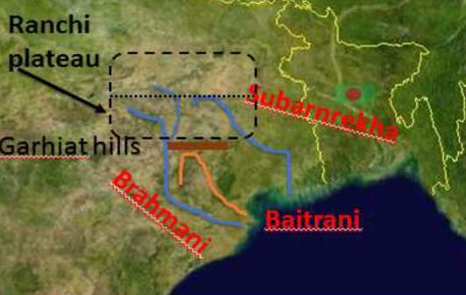

* Global Infrastructure facility – G20 initiative – Private financing & PPP

* Soil Health Card – Check overuse of fertilizers of soil quality
* Beverages have brominated vegetable oils to stabilize the beverage and prevent the flavours from floating on the beverage.
* WTO’s Trade facilitation agreement, 2013 – Bali Package – India is a member – Easing Export/Import

## 2018 –

* There is no tax credit in home countries for Equalization Levy
* Edible oil import > Edible oil domestic production

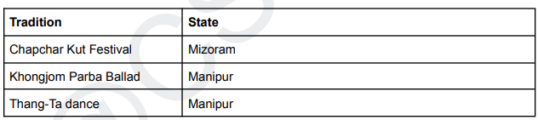

* ILO Convention 138, 182 – Child Labour
* Kirkuk, Mosul – Cities in Iraq
* Aleppo – City in Syria
* Mazar-i-sharif – City in Afghanistan
* Tyagaraja – Ram Bhakt
* Human Capital formation – accumulation of intangible wealth
* Uppada Jamdani – Andhra Pradesh; Puthukulli shawls – TN; Sujni embroidery – Bihar
* **Hind Mazdoor Sabha** – Ashok Mehta, TS Ramanujan, GG Mehta
* Jean Baptiste Tavernier – Discussed about Diamonds in India
* Kodaikanal is an artificial lake (Palani Hills)
* Partnership for action on green economy (PAGE) – UNCSD, 2012 – Rio+12
* Air India nationalization – 1953; SBI rename – 1955; Goa State – 1961
* Pakhui WS - Arunachal Pradesh
* Critical Wildlife Habitats – states initiate the process of notification, but it is done exclusively by the Central government.

## 2019 –

* Jagirdari – Military duty; Zamindari – Nobles – Revenue
* Neora Valley – WB; Valley of Flowers [Completely Temperate Alpine] - UK
* Atal innovation mission – NITI Ayog
* One horned rhino is not just naturally found in India.
* **Chandrabhaga** river – **Pandharpur** [Solapur, MH]
* Trichy – Cauvery River – Blue Finned Mahseer
* Himalayan Nettle – Textile Fibres
* Burning of Crop releases – O3, SO2, CO, CH4
* Glaciers –
  + Milam – Goriganga
  + Bandarpunch – Yamuna
  + Bara-singha – Chenab
  + Zemu – Teesta – Base of Kanchenjunga
  + Chorabari – Mandakini
* Pesticides – Carbofuran, Triazaphos, Methyl Parathion, Phorate
* Poultry releases reactive N2 compounds, Plants release NOx.

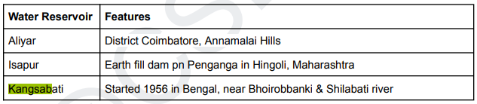

* PVTGs – Irular & Kondareddi
* UNODC – UN Office on Drugs and Crime manages -
  + UNCAC – UN Convention against Corruption
  + UNTOC – UN Convention against Transnational organized crime
  + SAFE Program
* Money at call = Money given at call
* Compensatory afforestation management and funding – Both at state + National level – People participation is not necessary.
* Appeals from PNGRB orders – Apellate Tribunal for electricity.
* Social Capital – Mutual trust and harmony in the society
* More Cotton area than sugarcane
* More oilseeds area than jowar
* RNAi => Can be used to treat Cancer

## 2020 –

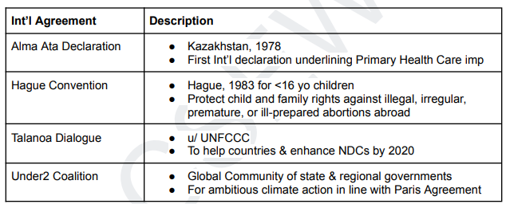

* Musk Deer – Found in Himalayan states – JK, HP, UK, Arunachal Pradesh
* Portland cement is not environmentally sustainable.
* Biochar promotes the growth of nitrogen fixing microorganisms and enables the growth medium to retain water for longer.
* Ports in the Gupta era - Ghantasala, Kadura, and Chaul
* NG 🡪 Ammonia 🡪 Urea
* Sulphur –
  + Raw material for Phosphoric Acid fertilizers
  + By-product of oil refineries
* Nagarjunsagar-srisailam has the largest area under Critical Tiger Habitat

## 2022 –

* Bar council of India – Attorney Gen + Solicitor Gen are ex-officio members.
* Ayushman Bharat Digital Mission – Under National Health Agency (Mo HFW)
* System of Rice intensification – Widely placed saplings, Alternate wet and dry irrigation, Organic manure

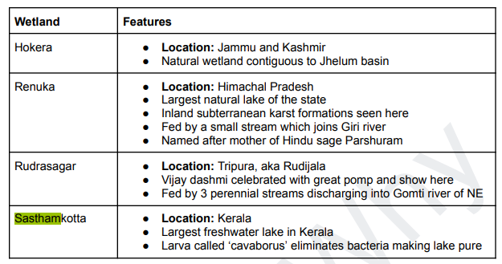

* WLAN – Short range device
* Climate Action Tracker – Climate Analytics + New climate institute
* Climate group is the secretariat of Under2 coalition.
  + Climate Group organizes EP100, RE100, Concrete zero, Steel zero etc.
* Mushrooms are fungi.

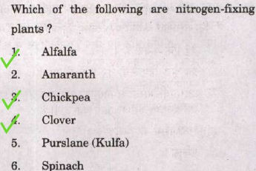

* Gajapati – 1431 to 1531
* ICRA – Public limited company
* Convertible bonds provide an indexation to inflation through the option to convert to Equity.

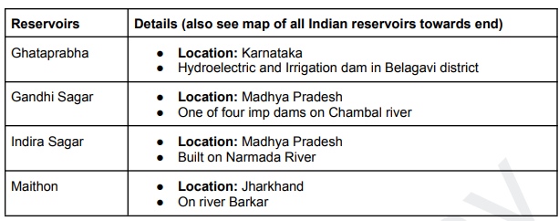

* Dams on Chambal – Gandhi Sagar, Jawahar Sagar, Rana Pratap Sagar, Kota Barrage
* Dams on Narmada – Sardar Sarovar, Indira Sagar
* National Technical Manpower information System – Mo Human Resource – Short term and long-term technical manpower requirement.
* Coal Controller’s Organization - Mo Coal – Annual Coal & Lignite Survey
* NIUA is not the apex body of Mo Housing and Urban affairs.
* Polar Code – International Maritime Organization
* Statutory boards under Mo Commerce –
  + Tea – Kolkata
  + Coffee – Bangalore
  + Rubber – Kottayam
  + Spices – Kochi
  + Tobacco – Guntur
* Statutory boards under Mo Textiles –
  + Central Silk Board – Bengaluru
  + National Jute Board – Kolkata
* Dadaab – Kenya
* BidiBidi – NW Uganda
* Organization of Turkic States – KATKU – Kazakhstan – Azerbaijan – Turkey – Krygztan – Uzbekistan
* Largest Solar Park in the world – Bhadle, RJ
* Largest Floating solar PV project – Simhadri River (AP)
* Fully Solar powered Int’l airport – Kerala
* Nizamuddin Panipati translated Yogavashishta during Akbar’s reign

* Eq Guinea – Permanent Chinese military base.